IVF / Fertility Clinic Management System
Patient
Requirements Specification
Software Engineering – Laboratory Deliverable
Roles: Albi Hoxha, Roberto Gjeta (Patient)
April 2026

1. Patient Role Overview
The Patient (Roberto, Albi) is the primary end-user of the IVF / Fertility Clinic Management System. Patients interact with the system through a self-service portal to manage their healthcare journey, from booking appointments to tracking their IVF cycle progress.
Core Responsibilities:
- Appointment Management: Book new appointments online by selecting a doctor, date, and time slot; cancel or reschedule existing appointments without needing to call the clinic.
- Test Results: View completed laboratory test results to stay informed about health status and treatment progress.
- Medical Records: View a read-only summary of medical history including diagnoses, prescriptions, and treatment plans entered by the doctor.
- Billing & Payments: View current and past bills with itemized charges, payment status, and outstanding balances.
- IVF Cycle Tracking: Monitor the progress of active IVF cycles through all phases (stimulation, egg retrieval, fertilization, embryo culture, transfer, luteal phase) with real-time updates from doctors and lab technicians.
- Notifications & Reminders: Receive timely reminders for upcoming appointments, medication schedules, and important cycle milestones.
- Feedback: Submit feedback about the clinic experience to support service improvement.
Access Level: The patient has read-only access to their own medical records, test results, bills, and IVF cycle data. Patients can create, cancel, and reschedule their own appointments. Patients cannot access other patients’ data, edit clinical records, or modify billing information. All patient actions are limited to their own account.

2. Functional Requirements
The following table lists all functional requirements specific to the Patient role. Each requirement is traceable to one or more user stories.
Req # | Requirement | Priority | Comments / Traceability
FR_P01 | The system shall provide the patient with an online appointment booking interface that displays available departments, doctors, and time slots for the next 30 days. | 1 | Supports US_P01. Only available slots are shown.
FR_P02 | The system shall prevent the patient from booking overlapping appointments and detect scheduling conflicts in real time. | 1 | Supports US_P01. Conflict detection runs on confirmation.
FR_P03 | The system shall allow the patient to cancel or reschedule an appointment online, provided the appointment is more than 24 hours away (configurable). | 1 | Supports US_P07. Cancellation requires a reason.
FR_P04 | The system shall display laboratory test results to the patient only after the results have been released by the requesting doctor. | 1 | Supports US_P02. Unreleased results show as ‘Under Review’.
FR_P05 | The system shall highlight abnormal test values visually and allow the patient to download test reports as PDF. | 1 | Supports US_P02. Includes reference ranges and units.
FR_P06 | The system shall display a read-only summary of the patient’s medical record including diagnoses, prescriptions, allergies, and treatment notes, organized chronologically. | 1 | Supports US_P03. Only the patient’s own records are visible.
FR_P07 | The system shall display current and past bills with itemized charges, taxes, insurance deductions, payment status, and outstanding balance. | 1 | Supports US_P04. Bills can be downloaded as PDF.
FR_P08 | The system shall display a visual timeline of the patient’s active IVF cycle showing all phases with real-time updates from doctors and lab technicians. | 1 | Supports US_P05. Updates within 5 minutes of data entry.
FR_P09 | The system shall send automated notification reminders for appointments (24h and 2h before), medication schedules, and IVF cycle milestones via the patient’s preferred channels. | 1 | Supports US_P06. Medication reminders cannot be disabled during active IVF cycle.
FR_P10 | The system shall allow the patient to update their contact information (phone, email, address) but restrict changes to critical fields (name, DOB, national ID) to administrators only. | 2 | Supports US_P08. Changes are logged with timestamps.
FR_P11 | The system shall allow the patient to submit feedback with a 1–5 star rating, free-text comment, and category tags, optionally linked to a specific appointment. | 2 | Supports US_P09. Rating is mandatory; comment is capped at 2000 chars.
FR_P12 | The system shall provide a calendar view of upcoming and past appointments filterable by status (upcoming, completed, cancelled). | 1 | Supports US_P10. Month and list views supported.
FR_P13 | The system shall display the patient’s active and past prescriptions with dosage, frequency, and special instructions, grouped by IVF cycle phase where applicable. | 1 | Supports US_P11. Active prescriptions distinguished from completed.
FR_P14 | The system shall provide a secure messaging interface allowing the patient to send and receive messages (with file attachments) to/from their assigned doctor. | 3 | Supports US_P12. Messages encrypted in transit and at rest.
FR_P15 | The system shall allow the patient to configure notification channels (email, SMS, both) and enable/disable specific reminder types, with safety exceptions for active IVF cycle medication reminders. | 2 | Supports US_P06. Medication reminders cannot be fully disabled during active cycle.
FR_P16 | The system shall display a patient portal dashboard with upcoming appointments, active cycle status, pending reminders, and recent notifications. | 2 | Dashboard must load within 2 seconds.
FR_P17 | The system shall implement role-based access control, restricting patients to read-only access of their own medical data and CRUD access only on their own appointments, profile contact fields, feedback, and messages. | 1 | Patients cannot view other patients’ data or edit clinical records.
FR_P18 | The system shall allow the patient to download their complete medical summary, test results, and bills as PDF documents with confidentiality notices. | 2 | Supports US_P02, US_P03, US_P04.

3. Non-Functional Requirements
The following non-functional requirements define the quality attributes of the system as they apply to the Patient’s experience and the data the patient interacts with.
Category | Req # | Requirement | Priority
Usability | NFR_P01 | The patient portal shall follow a consistent navigation pattern with clearly labeled sections (Dashboard, Appointments, Test Results, Medical Records, Bills, IVF Cycle, Messages, Feedback). | 1
Usability | NFR_P02 | All patient-facing forms shall provide inline validation with descriptive error messages before submission. | 1
Usability | NFR_P03 | The IVF cycle timeline shall include educational tooltips explaining each phase and common outcomes to reduce patient anxiety. | 2
Performance | NFR_P04 | The patient portal dashboard shall load within 2 seconds under normal network conditions. | 1
Performance | NFR_P05 | Doctor availability search results shall appear within 1 second of the patient selecting a service type. | 1
Performance | NFR_P06 | IVF cycle data shall update within 5 minutes of new data entry by a doctor or lab technician. | 1
Security | NFR_P07 | Patient passwords shall be stored using bcrypt hashing; plain-text storage is prohibited. | 1
Security | NFR_P08 | The system shall lock a patient account after 5 consecutive failed login attempts. | 1
Security | NFR_P09 | Authentication shall use JWT tokens with a maximum session duration of 4 hours, requiring re-authentication after expiry. | 1
Security | NFR_P10 | All patient portal communications shall use HTTPS/TLS encryption. Secure messages shall be encrypted at rest. | 1
Availability | NFR_P11 | The system shall be available 99.5% of the time (approximately 44 hours maximum downtime per year), excluding scheduled maintenance windows. | 1
Availability | NFR_P12 | Automated daily backups shall be performed, with the ability to restore data to any point within the last 30 days. | 1
Portability | NFR_P13 | The patient portal shall be a responsive web application compatible with Chrome, Firefox, Safari, and Edge on desktop, tablet, and mobile devices. | 1
Portability | NFR_P14 | The interface shall adapt to screen sizes from 375px (mobile) to 1920px (desktop) without loss of functionality. | 1
Data Protection | NFR_P15 | Patient personal and medical data shall be handled in compliance with Albanian Law No. 9887 on Protection of Personal Data and GDPR principles. | 1
Data Protection | NFR_P16 | SMS notifications shall not include sensitive medical details; only appointment time and a link to the portal. | 1
Maintainability | NFR_P17 | The system shall support scheduled maintenance windows with advance notification to patients, during which read-only access is maintained. | 2
Scalability | NFR_P18 | The system shall support at least 500 concurrent patient sessions without performance degradation. | 2

4. Patient User Stories
This section contains 12 user stories for the Patient role: 5 refined from the original requirements and 7 newly identified during analysis. Each story includes acceptance criteria that define when the story is considered complete.
Priorities: High = must-have for MVP (Sprint 1–2); Medium = important for Sprint 3–4; Low = nice-to-have.
ID | User Story | Acceptance Criteria | Pri. | Status
US_P01 | As a patient, I want to book an appointment online by selecting a doctor, date, and time slot so that I do not need to call the clinic. | Patient can search doctors by name or specialization. Only available time slots are displayed. System prevents double-booking for the same patient. Patient receives a confirmation notification (email/SMS) immediately after booking. Appointment appears in the patient’s portal with full details. | High | Refined
US_P02 | As a patient, I want to view my laboratory test results so that I can stay informed about my health status. | Test results appear in the portal once released by the doctor. Results display test name, date, values, and reference ranges. Abnormal values are highlighted visually. Patient can download results as PDF. Historical results are accessible and sortable by date. | High | Refined
US_P03 | As a patient, I want to view a summary of my medical record so that I can review my diagnosis and treatment plan. | Medical summary shows diagnoses, prescriptions, allergies, and treatment notes. Data is organized chronologically. Patient view is read-only (no editing). Only records from the patient’s own account are visible. Summary updates automatically when the doctor adds new entries. | High | Refined
US_P04 | As a patient, I want to see my current and past bills with payment status so that I can manage my expenses. | Bills display itemized services, amounts, taxes, and total due. Payment status (Pending, Partially Paid, Paid) is clearly shown. Patient can view payment history for each bill. Outstanding balance is displayed prominently. Bills can be downloaded as PDF. | High | Refined
US_P05 | As a patient, I want to track my IVF cycle progress (stimulation, retrieval, fertilization, transfer) so that I understand where I am in the process. | Current cycle phase is displayed with a visual timeline. Completed phases show dates and outcomes. Embryo culture phase shows embryo count, grades, and development notes. Patient can view past cycle history. Cycle data updates in near-real-time as doctor/lab enters information. | High | Refined
US_P06 | As a patient, I want to receive notification reminders for upcoming appointments and medication schedules so that I do not miss critical steps. | Appointment reminders are sent 24 hours and 2 hours before the scheduled time. Medication reminders include dosage, timing, and special instructions. Notifications are delivered via email and/or SMS based on patient preference. Patient can view all upcoming reminders in the portal. Missed medication reminders trigger a follow-up notification. | High | New
US_P07 | As a patient, I want to cancel or reschedule an appointment online so that I can adjust my schedule without calling the clinic. | Patient can cancel an appointment with a reason. Patient can select a new date/time when rescheduling. Cancellation/rescheduling is only allowed up to 24 hours before the appointment (configurable). Both the patient and doctor are notified of the change. Cancelled time slots become available for other patients. | Medium | New
US_P08 | As a patient, I want to update my personal contact information so that the clinic can reach me with accurate details. | Patient can edit phone number, email, and address. Changes are logged with a timestamp. Critical fields (name, DOB, national ID) cannot be changed by the patient (admin only). Updated contact details are reflected immediately across the system. Patient receives a confirmation of the update. | Medium | New
US_P09 | As a patient, I want to submit feedback about my clinic experience so that the clinic can improve its services. | Feedback form includes rating (1–5) and free-text comment. Feedback can be linked to a specific appointment or submitted generally. Submission is acknowledged with a confirmation message. Feedback is anonymous to clinical staff (only admin can view identity if needed). Patient can view their own submitted feedback history. | Low | New
US_P10 | As a patient, I want to view my upcoming and past appointments in a calendar view so that I can plan my schedule. | Calendar shows all appointments with date, time, doctor, and service type. Upcoming appointments are highlighted differently from past ones. Patient can filter by status (upcoming, completed, cancelled). Clicking an appointment shows full details. Calendar supports month and list views. | High | New
US_P11 | As a patient, I want to view my prescribed medications and dosage instructions so that I follow my treatment plan correctly. | Medications list shows name, dosage, frequency, start/end dates, and prescribing doctor. Active prescriptions are distinguished from completed ones. Special instructions (e.g., take with food, refrigerate) are prominently displayed. Medication list is linked to the relevant IVF cycle phase. Patient can set medication reminders from this view. | High | New
US_P12 | As a patient, I want to securely message my doctor through the portal so that I can ask questions without needing a phone call. | Patient can compose and send messages to their assigned doctor. Messages support text and file attachments (images, PDFs). Patient receives a notification when the doctor replies. Conversation history is preserved and searchable. Messages are encrypted in transit and at rest. | Low | New

5. User Scenarios List
The following table summarizes all user scenarios for the Patient role. Each scenario is expanded in detail in Section 6.
ID | Scenario Name | Description
SC_P01 | Patient logs in | Patient logs in using username and password and is redirected to the patient portal dashboard.
SC_P02 | Book an appointment | Patient books a new appointment by selecting a service, doctor, date, and time slot.
SC_P03 | Cancel an appointment | Patient cancels an existing appointment online with a cancellation reason.
SC_P04 | Reschedule an appointment | Patient reschedules an existing appointment to a new date/time with the same or different doctor.
SC_P05 | View test results | Patient views laboratory test results, reviews values and reference ranges, and downloads reports.
SC_P06 | View medical record summary | Patient views their read-only medical history including diagnoses, prescriptions, and treatment notes.
SC_P07 | View bills and payment status | Patient views current and past bills with itemized charges, payment history, and outstanding balance.
SC_P08 | Track IVF cycle progress | Patient monitors the visual timeline of their active IVF cycle, including phase updates and embryo data.
SC_P09 | Update contact information | Patient updates their phone number, email, or address in their profile.
SC_P10 | View appointment calendar | Patient views upcoming and past appointments in a calendar or list view.
SC_P11 | View prescribed medications | Patient views their active and past prescriptions with dosage and instructions.
SC_P12 | Submit feedback | Patient submits a rating and comment about their clinic experience, optionally linked to an appointment.
SC_P13 | Send a message to doctor | Patient composes and sends a secure message to their assigned doctor through the portal.
SC_P14 | Manage notification preferences | Patient configures their notification channels and enables/disables specific reminder types.
SC_P15 | View portal dashboard | Patient views the portal dashboard with upcoming appointments, active cycle status, pending reminders, and recent notifications.

6. User Scenarios Extended
Each user scenario is expanded below with step-by-step flows, including both the normal path and exception handling.

SC_P01: Patient logs in
1. Patient navigates to the portal login page.
2. Patient enters username (email) and password.
3. Patient clicks ‘Login’.
4. System validates credentials.
5. System identifies the user role as Patient.
6. System redirects to the Patient portal dashboard.
7. If credentials are invalid: system displays an error message and prompts retry.
8. After 5 failed attempts: system locks the account and displays a contact-support message.
9. If contact information has not been updated in 90 days: system prompts the patient to verify their details.

SC_P02: Book an appointment
1. Patient clicks ‘Book Appointment’ from the portal dashboard.
2. System displays available departments/services.
3. Patient selects a service type.
4. System displays doctors available for the selected service with name, specialization, and next available slot.
5. Patient selects a doctor.
6. System displays the doctor’s available dates and time slots for the next 30 days.
7. Patient selects a date and time slot.
8. System displays a booking summary: service, doctor, date, time, and estimated duration.
9. Patient adds optional notes (reason for visit, special requests).
10. Patient clicks ‘Confirm Booking’.
11. System checks for scheduling conflicts (patient’s existing appointments and doctor’s schedule).
12. If conflict found: system displays warning and suggests alternative slots.
13. System creates the appointment with status ‘Confirmed’.
14. System sends a confirmation notification (email/SMS) to the patient.
15. System displays confirmation with appointment details and a calendar download option (.ics).

SC_P03: Cancel an appointment
1. Patient navigates to ‘My Appointments’.
2. System displays upcoming appointments.
3. Patient selects the appointment to cancel.
4. System displays appointment details and cancellation policy.
5. If appointment is within 24 hours: system shows message that online cancellation is not permitted and advises calling the clinic.
6. Patient clicks ‘Cancel Appointment’.
7. System prompts for a cancellation reason (dropdown + optional free text).
8. Patient submits the reason.
9. System cancels the appointment and releases the time slot.
10. If a room was assigned: system releases the room.
11. System sends cancellation notifications to the patient and doctor.
12. System displays confirmation of cancellation.

SC_P04: Reschedule an appointment
1. Patient navigates to ‘My Appointments’ and selects the appointment.
2. Patient clicks ‘Reschedule’.
3. If appointment is within 24 hours: system shows message that online rescheduling is not permitted.
4. System displays available time slots for the same doctor.
5. Patient selects a new date and time.
6. System checks for conflicts.
7. If conflict: system notifies the patient and asks to select a different slot.
8. System updates the appointment with the new date/time.
9. System sends notifications to the patient and doctor.
10. System displays the updated appointment details.

SC_P05: View test results
1. Patient navigates to ‘My Test Results’ from the portal dashboard.
2. System displays a list of all test reports, sorted by date (most recent first).
3. Each entry shows: test name, date, ordering doctor, and status (Pending, Under Review, Available).
4. Patient selects a test report to view.
5. System displays the full report: test parameters, measured values, reference ranges, units, and lab notes.
6. Abnormal values are highlighted in red with a visual indicator.
7. Patient can download the report as a PDF.
8. Patient can navigate between reports using Previous/Next buttons.
9. If no results are available: system displays ‘No test results available yet’ with pending test orders and expected dates.

SC_P06: View medical record summary
1. Patient navigates to ‘My Medical Records’ from the portal dashboard.
2. System retrieves the patient’s medical history.
3. System displays the summary organized in sections: Personal Info, Allergies, Diagnoses, Prescriptions, Treatment Notes, IVF Cycle History.
4. Each entry shows the date, doctor name, and content.
5. Entries are sorted chronologically (most recent first).
6. Patient can expand/collapse sections for easier navigation.
7. Patient can filter entries by date range or category.
8. Patient can download the full summary as a PDF.
9. If no records exist: system displays ‘No medical records available yet. Records will appear after your first consultation.’

SC_P07: View bills and payment status
1. Patient navigates to ‘My Bills’ from the portal dashboard.
2. System displays a list of all bills sorted by date (most recent first).
3. Each bill entry shows: invoice number, date, total amount, amount paid, balance due, and status (Pending, Partially Paid, Paid).
4. Patient selects a bill to view details.
5. System displays the itemized bill: service name, date of service, unit price, quantity, line total, subtotal, taxes, insurance coverage, discounts, and total due.
6. System displays the payment history for the selected bill.
7. Patient can download the bill as a PDF.
8. If patient believes a bill is incorrect: patient clicks ‘Report Issue’ to send a query to the administrator.

SC_P08: Track IVF cycle progress
1. Patient navigates to ‘My IVF Cycle’ from the portal dashboard.
2. System displays the current cycle with a visual timeline showing all phases: Stimulation, Egg Retrieval, Fertilization, Embryo Culture, Transfer, Luteal Phase.
3. The current active phase is highlighted on the timeline.
4. Completed phases show dates, outcomes, and a green checkmark.
5. Patient clicks on the current phase to see detailed information.
6. For Stimulation: system shows medication dosages, injection schedule, and upcoming monitoring appointments.
7. For Egg Retrieval: system shows date, number of eggs retrieved, and doctor’s notes.
8. For Fertilization: system shows number of eggs fertilized and method used (conventional IVF or ICSI).
9. For Embryo Culture: system shows embryo count, daily development grades, and lab technician’s observations.
10. For Transfer: system shows date, number of embryos transferred, and doctor’s notes.
11. For Luteal Phase: system shows follow-up schedule, hormone support medications, and pregnancy test date.
12. Patient can switch between current and past cycles using a cycle selector.
13. If no active cycle: system displays past cycle history or a message to consult the doctor.

SC_P09: Update contact information
1. Patient navigates to ‘My Profile’.
2. System displays the current profile with personal and contact details.
3. Patient clicks ‘Edit’ on the contact information section.
4. Patient updates the relevant fields (phone number, email, address).
5. Critical fields (name, DOB, national ID) are displayed as read-only.
6. Patient clicks ‘Save Changes’.
7. System validates the updated fields (email format, phone format).
8. If validation fails: system highlights errors; patient corrects and resubmits.
9. System saves the changes with a timestamp.
10. Patient receives a confirmation notification of the update.
11. Updated details are reflected immediately across the system.

SC_P10: View appointment calendar
1. Patient navigates to ‘My Appointments’.
2. System displays appointments in a calendar view (default: month view).
3. Upcoming appointments are highlighted in blue; past appointments in grey; cancelled in red.
4. Patient can switch between month view and list view.
5. Patient can filter by status (upcoming, completed, cancelled).
6. Patient clicks an appointment to view full details (doctor, service type, room, time, notes).
7. From the detail view, patient can reschedule or cancel (if eligible).

SC_P11: View prescribed medications
1. Patient navigates to ‘My Medications’ from the portal dashboard.
2. System displays a list of all prescriptions, with active ones at the top.
3. Each entry shows: medication name, dosage, frequency, start/end dates, prescribing doctor, and status (Active, Completed).
4. Patient selects a prescription to see full details including special instructions.
5. Medications linked to an active IVF cycle are grouped and labeled with the cycle phase.
6. Patient can set a medication reminder from this view.
7. If no prescriptions exist: system displays ‘No prescriptions found.’

SC_P12: Submit feedback
1. Patient navigates to ‘Submit Feedback’ from the portal or from a completed appointment’s detail page.
2. System displays the feedback form.
3. If accessed from an appointment: system pre-fills the appointment date, doctor, and service type.
4. Patient selects a rating (1–5 stars).
5. Patient enters a free-text comment (optional).
6. Patient selects feedback categories (waiting time, staff friendliness, facility cleanliness, communication, treatment quality).
7. Patient clicks ‘Submit Feedback’.
8. System validates the submission (rating is required, comment max 2000 characters).
9. If validation fails: system highlights the required field.
10. System saves the feedback and displays a confirmation message.
11. Feedback is sent to the clinic’s quality management queue.

SC_P13: Send a message to doctor
1. Patient navigates to ‘Messages’ from the portal.
2. Patient clicks ‘New Message’ and selects the assigned doctor as the recipient.
3. Patient types the message and optionally attaches files (images, PDFs).
4. Patient clicks ‘Send’.
5. System encrypts the message and delivers it to the doctor’s inbox.
6. Patient receives a notification when the doctor replies.
7. Conversation history is preserved and searchable.
8. If attachment exceeds size limit: system shows an error and prompts the patient to reduce file size.

SC_P14: Manage notification preferences
1. Patient navigates to ‘Notification Settings’ from the profile menu.
2. System displays configurable notification types (appointments, medications, cycle milestones, test results, billing).
3. Patient selects preferred channels per type (email, SMS, both, or disabled).
4. System enforces that medication reminders during active IVF cycles cannot be fully disabled.
5. Patient clicks ‘Save Preferences’.
6. System stores preferences and applies them immediately to future notifications.

SC_P15: View portal dashboard
1. Patient logs in (redirected to dashboard) or clicks ‘Dashboard’ in navigation.
2. System loads the dashboard within 2 seconds.
3. Dashboard shows: next upcoming appointment, active IVF cycle phase summary, pending medication reminders, recent test results (if released), outstanding bill balance, and recent notifications.
4. Patient can click any section to navigate to its detailed view.

7. Use Cases – Patient User Flows
Each use case describes the full user flow for the patient, following the structured format from the course case study. Each includes: description, preconditions, main flow, alternative/exception paths, what can go wrong, postconditions, restrictions and constraints, and related user stories.

7.1 UC_P01: Book Appointment
UC Name | Book Appointment
UC ID | UC_P01
Actors | Patient (primary), Hospital Administrator (secondary – can book on behalf)
Description | The patient books a new appointment through the self-service portal by selecting a department/service, choosing a doctor, and picking an available date and time slot. The system validates the selection, prevents conflicts, and sends confirmation notifications to both the patient and the doctor.
Preconditions | Patient is authenticated and logged into the portal. Patient’s account is active and registration is complete. At least one doctor has available time slots within the patient’s selected date range.
Main Flow (Normal) | 1. Patient navigates to ‘Book Appointment’ from the portal dashboard. 2. System displays available departments/services (e.g., IVF Consultation, General Check-up, Follow-up, Procedure). 3. Patient selects the desired service type. 4. System displays a list of doctors available for the selected service, showing name, specialization, and next available slot. 5. Patient selects a preferred doctor. 6. System retrieves and displays the doctor’s available dates and time slots for the next 30 days. 7. Patient selects a date and time slot. 8. System displays a booking summary: service, doctor, date, time, and estimated duration. 9. Patient adds optional notes (reason for visit, special requests, mobility needs). 10. Patient clicks ‘Confirm Booking’. 11. System checks for scheduling conflicts (patient’s existing appointments and doctor’s schedule). 12. System creates the appointment with status ‘Confirmed’. 13. System sends a confirmation notification (email/SMS) to the patient. 14. System updates the doctor’s schedule. 15. System displays the confirmation screen with appointment details and a calendar download option (.ics).
Alternative / Exception Flow | 4a. No doctors available for selected service: System displays a message suggesting alternative dates or service types. 6a. No available slots for the selected doctor in the next 30 days: System offers to show the earliest available slot beyond 30 days and suggests alternative doctors. 11a. Patient already has an appointment at the selected time: System displays a conflict warning; patient must select a different time slot. 11b. Doctor’s slot was just taken (race condition): System notifies the patient, refreshes available slots. Cancel path: Patient can abandon the booking at any step; no appointment is created.
What Can Go Wrong | Patient may book the wrong service type. Mitigation: service descriptions with clear explanations are shown. Network failure during confirmation could leave the booking incomplete. Mitigation: booking uses a transactional save. Confirmation notification may fail to deliver. Mitigation: system logs delivery failures; appointment is still visible in the portal.
Postconditions | A new appointment record exists with status ‘Confirmed’. The doctor’s schedule reflects the booking. The patient can see the appointment in their portal. Both the patient and doctor receive confirmation notifications. The booking event is logged in the audit trail.
Restrictions & Constraints | Appointments must be booked at least 24 hours in advance (configurable by admin). Appointments can only be scheduled during the doctor’s configured availability hours. A patient cannot have overlapping appointments. A doctor cannot have overlapping appointments. Booking is limited to clinic operating hours. Only authenticated, registered patients can book appointments. The system must respond to booking requests within 3 seconds.
Related User Stories | US_P01, US_P06, US_P07, US_P10
Dependencies | None (this is a standalone patient-initiated use case). Patient registration (performed by Administrator via UC_A01) must be completed before the patient can book.

7.2 UC_P02: Cancel or Reschedule Appointment
UC Name | Cancel or Reschedule Appointment
UC ID | UC_P02
Actors | Patient
Description | The patient cancels an existing appointment or reschedules it to a new date/time through the portal. The system enforces cancellation policies, releases the original time slot, and notifies all affected parties.
Preconditions | Patient is authenticated and logged in. The patient has at least one upcoming appointment with status ‘Confirmed’. The appointment is more than 24 hours away (within the cancellation policy window).
Main Flow (Normal) | Cancellation path: 1. Patient navigates to ‘My Appointments’. 2. System displays upcoming appointments. 3. Patient selects the appointment to cancel. 4. System displays appointment details and cancellation policy. 5. Patient clicks ‘Cancel Appointment’. 6. System prompts for a cancellation reason (dropdown + optional free text). 7. Patient submits the reason. 8. System cancels the appointment and releases the time slot. 9. If a room was assigned, system releases the room. 10. System sends cancellation notifications to the patient and doctor. 11. System displays confirmation of cancellation. Rescheduling path: 1. Patient navigates to ‘My Appointments’ and selects the appointment. 2. Patient clicks ‘Reschedule’. 3. System displays available time slots for the same doctor. 4. Patient selects a new date and time. 5. System checks for conflicts. 6. System updates the appointment with the new date/time. 7. System sends notifications to the patient and doctor. 8. System displays the updated appointment details.
Alternative / Exception Flow | 4a. Appointment is within 24 hours: System displays a message that online cancellation is not permitted; advises calling the clinic. 3a. (Reschedule) No available slots for the same doctor: System suggests alternative doctors or dates. 5a. (Reschedule) Conflict detected: System notifies the patient and asks to select a different slot.
What Can Go Wrong | Patient cancels too many appointments. Mitigation: system tracks cancellation frequency; after 3 in 30 days, warning shown and admin notified. Rescheduling notification may not reach the doctor in time. Mitigation: notifications sent immediately; changes within 48 hours trigger both email and SMS. Patient may accidentally cancel the wrong appointment. Mitigation: confirmation step shows full appointment details.
Postconditions | Appointment is cancelled or rescheduled as requested. Original time slot is released for other patients. Doctor’s schedule is updated. Both parties are notified of the change. The change is logged in the audit trail.
Restrictions & Constraints | Cancellation/rescheduling is only allowed 24+ hours before the appointment (configurable). Cancellation requires a reason. The system must preserve a record of cancelled appointments for audit. Rescheduled appointments follow the same conflict-checking rules as new bookings. Only the patient or an administrator can cancel/reschedule a patient’s appointment.
Related User Stories | US_P07, US_P01, US_P10
Dependencies | UC_P01 (Book Appointment) — An appointment must exist before it can be cancelled or rescheduled.

7.3 UC_P03: View Test Results
UC Name | View Test Results
UC ID | UC_P03
Actors | Patient
Description | The patient views their laboratory test results through the portal. Results are available after they have been uploaded by the lab technician and released by the requesting doctor. The patient can review values, reference ranges, and download reports.
Preconditions | Patient is authenticated and logged in. At least one test result has been uploaded and released for the patient.
Main Flow (Normal) | 1. Patient navigates to ‘My Test Results’ from the portal dashboard. 2. System displays a list of all test reports, sorted by date (most recent first). 3. Each entry shows: test name, date, ordering doctor, and status (Pending, Available). 4. Patient selects a test report to view. 5. System displays the full report: test parameters, measured values, reference ranges, units, and lab notes. 6. Abnormal values are highlighted in red with a visual indicator. 7. Patient can download the report as a PDF. 8. Patient can navigate between reports using Previous/Next buttons.
Alternative / Exception Flow | 2a. No test results available: System displays ‘No test results available yet’ with pending test orders and expected completion dates. 3a. Test status is ‘Pending’: System shows the test name and order date but no results. 3b. Results uploaded but not released by the doctor: Results are not visible; system shows status as ‘Under Review’.
What Can Go Wrong | Patient may misinterpret abnormal values. Mitigation: results page includes a disclaimer advising patients to consult their doctor. Results may be delayed due to lab processing. Mitigation: expected completion dates shown for pending tests. PDF download may fail on certain devices. Mitigation: both PDF and web-view options provided.
Postconditions | Patient has viewed the test results. View event is logged (for tracking patient engagement). No data is modified by this use case.
Restrictions & Constraints | Patients can only view their own test results. Results are only visible after doctor release (configurable policy). Test result data is read-only for patients. All test result views are logged for compliance. Downloaded PDFs include the patient’s name, date, and a confidentiality notice.
Related User Stories | US_P02, US_P03
Dependencies | UC_P01 (Book Appointment) — The patient must have had an appointment that led to a test order. Lab Technician must have uploaded results, and the Doctor must have released them.

7.4 UC_P04: View Medical Record Summary
UC Name | View Medical Record Summary
UC ID | UC_P04
Actors | Patient
Description | The patient views a read-only summary of their medical record including diagnoses, prescriptions, treatment plans, allergies, and clinical notes entered by their doctor.
Preconditions | Patient is authenticated and logged in. The patient has at least one medical record entry created by a doctor.
Main Flow (Normal) | 1. Patient navigates to ‘My Medical Records’ from the portal dashboard. 2. System retrieves the patient’s medical history. 3. System displays the summary organized in sections: Personal Info, Allergies, Diagnoses, Prescriptions, Treatment Notes, IVF Cycle History. 4. Each entry shows the date, doctor name, and content. 5. Entries are sorted chronologically (most recent first). 6. Patient can expand/collapse sections for easier navigation. 7. Patient can filter entries by date range or category. 8. Patient can download the full summary as a PDF.
Alternative / Exception Flow | 2a. No medical records found: System displays ‘No medical records available yet. Records will appear after your first consultation.’ 8a. PDF generation fails: System displays an error message and offers to retry.
What Can Go Wrong | Patient may find outdated information if the doctor has not yet updated the record. Mitigation: each entry displays the date it was last modified. The medical summary may be overwhelming for patients with long treatment histories. Mitigation: collapsible sections and date filters.
Postconditions | Patient has viewed their medical summary. No data is modified. View event is logged.
Restrictions & Constraints | Patients can only view their own medical records. Medical records are strictly read-only for patients. Patients cannot delete, edit, or annotate medical record entries. Clinical notes flagged as ‘Doctor Only’ are not visible to the patient. All views are logged for compliance and audit purposes. Data must comply with local data protection regulations (Albanian Law No. 9887).
Related User Stories | US_P03, US_P02, US_P11
Dependencies | UC_P01 (Book Appointment) — At least one consultation must have occurred for medical records to exist. Doctor must have entered clinical data.

7.5 UC_P05: View Bills and Payment Status
UC Name | View Bills and Payment Status
UC ID | UC_P05
Actors | Patient
Description | The patient views their current and past bills through the portal, including itemized charges, taxes, insurance deductions, payment status, and outstanding balances.
Preconditions | Patient is authenticated and logged in. At least one bill has been generated for the patient by the administrator.
Main Flow (Normal) | 1. Patient navigates to ‘My Bills’ from the portal dashboard. 2. System displays a list of all bills sorted by date (most recent first). 3. Each bill entry shows: invoice number, date, total amount, amount paid, balance due, and status (Pending, Partially Paid, Paid). 4. Patient selects a bill to view details. 5. System displays the itemized bill: service name, date of service, unit price, quantity, line total, subtotal, taxes, insurance coverage (if applicable), discounts, and total due. 6. System displays the payment history for the selected bill. 7. Patient can download the bill as a PDF. 8. Patient returns to the bill list or navigates to another bill.
Alternative / Exception Flow | 2a. No bills available: System displays ‘No bills have been generated yet.’ 6a. No payments recorded: Payment history section shows ‘No payments recorded for this bill.’ Insurance path: If the patient has insurance, the bill shows the covered amount and the patient’s co-pay separately.
What Can Go Wrong | Patient may see a bill they believe is incorrect. Mitigation: bill detail page includes a ‘Report Issue’ button that sends a query to the administrator. Billing data may be slow to update after a recent payment. Mitigation: payment status updates are reflected within 15 minutes of recording.
Postconditions | Patient has viewed their billing information. No financial data is modified by this use case. View event is logged.
Restrictions & Constraints | Patients can only view their own bills. Billing data is read-only for patients. Patients cannot make payments through the portal (payments are recorded by the administrator). Bills cannot be deleted or modified by patients. Downloaded PDF invoices include clinic details, patient name, and a confidentiality notice. Billing records must be retained for a minimum of 5 years (regulatory compliance).
Related User Stories | US_P04, US_P01
Dependencies | UC_P01 (Book Appointment) — Services must have been rendered through appointments. Administrator must have generated the bill (UC_A03).

7.6 UC_P06: Track IVF Cycle Progress
UC Name | Track IVF Cycle Progress
UC ID | UC_P06
Actors | Patient (primary), Doctor (updates phases), Lab Technician (updates embryo data)
Description | The patient monitors the progress of their active IVF treatment cycle through the portal. The system displays a visual timeline of all phases, real-time updates from doctors and lab technicians, embryo development data, and medication schedules.
Preconditions | Patient is authenticated and logged in. Patient has an active or completed IVF cycle initiated by a doctor. Lab technician has access to the embryology module for data entry.
Main Flow (Normal) | 1. Patient navigates to ‘My IVF Cycle’ from the portal dashboard. 2. System displays the current cycle with a visual timeline showing all phases: Stimulation, Egg Retrieval, Fertilization, Embryo Culture, Transfer, Luteal Phase. 3. The current active phase is highlighted on the timeline. 4. Completed phases show dates, outcomes, and a green checkmark. 5. Patient clicks on the current phase to see detailed information. 6. For Stimulation: system shows medication dosages, injection schedule, and upcoming monitoring appointments. 7. For Egg Retrieval: system shows date, number of eggs retrieved, and doctor’s notes. 8. For Fertilization: system shows number of eggs fertilized and method used (conventional IVF or ICSI). 9. For Embryo Culture: system shows embryo count, daily development grades (cell count, fragmentation, morphology), and lab technician’s observations. 10. For Transfer: system shows date, number of embryos transferred, and doctor’s notes. 11. For Luteal Phase: system shows follow-up schedule, hormone support medications, and pregnancy test date. 12. Patient can switch between current and past cycles using a cycle selector.
Alternative / Exception Flow | 2a. No active cycle: System displays past cycle history (if any). If no cycles exist: ‘No IVF cycles recorded. Please consult your doctor to start a cycle.’ 9a. Embryo data not yet entered for today: System displays ‘Awaiting lab update’ with expected update time. Cycle cancellation: If the doctor cancels the cycle, the patient sees status as ‘Cancelled’ with the reason and recommended next steps. Multiple cycles: Patient can compare past cycle outcomes side by side.
What Can Go Wrong | Patient may experience anxiety seeing embryo grades decline. Mitigation: educational tooltips explaining that development variation is normal. Lab data may be delayed. Mitigation: each data point shows the timestamp of the last update. System downtime during a critical cycle phase. Mitigation: proactive notifications for significant cycle events.
Postconditions | Patient has viewed their IVF cycle progress. No data is modified by the patient. View event is logged.
Restrictions & Constraints | Patients can only view their own cycle data. Cycle data is read-only for patients. Cycle phase transitions require doctor authorization. All embryo data entries are immutable once confirmed (append-only). Embryo grading must follow the clinic’s standardized grading system. The cycle timeline must update within 5 minutes of new data entry. Patient data must comply with local data protection laws.
Related User Stories | US_P05, US_P02, US_P06, US_P11
Dependencies | UC_P01 (Book Appointment) — An initial consultation appointment is required. Doctor must have initiated an IVF cycle. Lab Technician must enter embryo data for the Embryo Culture phase.

7.7 UC_P07: Receive Notification Reminders
UC Name | Receive Notification Reminders
UC ID | UC_P07
Actors | Patient (recipient), System (sender)
Description | The system sends automated notification reminders to the patient for upcoming appointments, medication schedules, and important IVF cycle milestones. The patient can view, manage, and configure their notification preferences through the portal.
Preconditions | Patient is authenticated and has a valid email and/or phone number on file. Patient has upcoming appointments, active prescriptions, or an active IVF cycle. Notification service is operational.
Main Flow (Normal) | 1. System identifies upcoming events requiring notification (scheduled via background job). 2. For appointments: system sends a reminder 24 hours before and 2 hours before the scheduled time. 3. For medications: system sends reminders at the prescribed times with dosage and instructions. 4. For IVF milestones: system sends notifications when a new cycle phase begins, when embryo data is updated, and when test results are available. 5. Notifications are delivered via the patient’s preferred channels (email, SMS, or both). 6. Notification appears in the portal’s notification center. 7. Patient can click a notification to navigate to the relevant section. 8. Patient can mark notifications as read.
Alternative / Exception Flow | 5a. Email/SMS delivery fails: System retries delivery up to 3 times at 5-minute intervals. Failed notifications are logged and visible in the portal. Admin is alerted if failures persist. Patient preference management: Patient navigates to ‘Notification Settings’ to enable/disable notification types and choose delivery channels. Medication reminders cannot be fully disabled during an active IVF cycle (safety requirement).
What Can Go Wrong | Notifications may go to an outdated phone number or email. Mitigation: system prompts patients to verify contact info if not updated in 90 days. Excessive notifications may cause the patient to ignore important ones. Mitigation: critical notifications are visually distinguished. Timezone differences may cause reminders at inconvenient times. Mitigation: system respects the patient’s configured timezone.
Postconditions | Notifications are delivered to the patient via configured channels. Notification delivery status is logged. Patient’s notification center is updated.
Restrictions & Constraints | Medication reminders during an active IVF cycle cannot be fully disabled (patient safety). Notifications must be sent within 1 minute of the scheduled trigger time. All notification content must avoid including sensitive medical details in SMS. Notification preferences are stored per patient and can be changed at any time. The system must support Albanian and English notification templates. Notification history must be retained for 12 months.
Related User Stories | US_P06, US_P01, US_P11, US_P05
Dependencies | UC_P01 (Book Appointment) — Appointment reminders depend on existing bookings. UC_P06 (Track IVF Cycle Progress) — Cycle milestone notifications depend on an active cycle. Medication reminders depend on active prescriptions entered by the Doctor.

7.8 UC_P08: Submit Feedback
UC Name | Submit Feedback
UC ID | UC_P08
Actors | Patient
Description | The patient submits feedback about their clinic experience through the portal. Feedback can be general or linked to a specific appointment. This supports the clinic’s quality improvement initiatives and provides measurable patient satisfaction data.
Preconditions | Patient is authenticated and logged in. Patient has had at least one appointment at the clinic (for appointment-linked feedback).
Main Flow (Normal) | 1. Patient navigates to ‘Submit Feedback’ from the portal or from a completed appointment’s detail page. 2. System displays the feedback form. 3. If accessed from an appointment: system pre-fills the appointment date, doctor, and service type. 4. Patient selects a rating (1–5 stars). 5. Patient enters a free-text comment (optional but encouraged). 6. Patient selects feedback categories (e.g., waiting time, staff friendliness, facility cleanliness, communication, treatment quality). 7. Patient clicks ‘Submit Feedback’. 8. System validates the submission (rating is required, comment max 2000 characters). 9. System saves the feedback and displays a confirmation message. 10. System sends the feedback to the clinic’s quality management queue.
Alternative / Exception Flow | 3a. General feedback (not linked to an appointment): Appointment fields are left empty or patient selects ‘General Feedback’. 8a. Validation fails (no rating selected): System highlights the required field; patient adds the rating and resubmits. Follow-up path: If the clinic responds to the feedback, the patient receives a notification and can view the response in their feedback history.
What Can Go Wrong | Patient may submit feedback intended for a different appointment. Mitigation: confirmation step shows the linked appointment details. Abusive or inappropriate content in free-text comments. Mitigation: comments are reviewed by the administrator before being shared with clinical staff.
Postconditions | Feedback is recorded in the system. Feedback appears in the patient’s feedback history. Feedback is available in the administrator’s quality management queue. Patient receives a confirmation message.
Restrictions & Constraints | Rating (1–5) is a mandatory field. Free-text comments are limited to 2000 characters. Feedback identity is anonymous to clinical staff; only the administrator can view the patient’s identity if needed. Patients can submit feedback up to 30 days after an appointment. Feedback cannot be edited after submission; patient can submit a new entry. Only authenticated patients can submit feedback.
Related User Stories | US_P09, US_P01
Dependencies | UC_P01 (Book Appointment) — For appointment-linked feedback, a completed appointment must exist. General feedback has no dependencies beyond patient authentication.

8. Use Case Diagram
The Use Case Diagram below describes the Patient actor and all use cases they interact with. The diagram follows UML notation with «include» and «extend» relationships where applicable.
Actors:
- Patient (primary) – Roberto, Albi
- Hospital Administrator (secondary) – can perform some actions on behalf of the patient
- Doctor (secondary) – updates medical records, releases test results, authorizes cycle phases
- Lab Technician (secondary) – enters embryology data viewed by the patient
- System (secondary) – sender of automated notifications
Primary Use Cases (direct interactions):
- Book Appointment – Patient books a new appointment by selecting service, doctor, and time slot.
- Cancel Appointment – Patient cancels an upcoming appointment with a mandatory reason.
- Reschedule Appointment – Patient moves an upcoming appointment to a different date/time.
- View Test Results – Patient views released laboratory test results with abnormal value highlighting.
- View Medical Record Summary – Patient views read-only diagnoses, prescriptions, allergies, and notes.
- View Bills and Payment Status – Patient views itemized bills and payment history.
- Track IVF Cycle Progress – Patient monitors the visual timeline of their active IVF cycle.
- View Appointment Calendar – Patient views upcoming and past appointments in calendar/list view.
- View Prescribed Medications – Patient views active and past prescriptions with dosage instructions.
- Update Contact Information – Patient edits their phone, email, and address.
- Submit Feedback – Patient submits a rating and comment about their clinic experience.
- Send Message to Doctor – Patient sends a secure message to their assigned doctor.
- Manage Notification Preferences – Patient configures notification channels and types.
- View Dashboard – Patient views the portal overview with key metrics and upcoming events.
«include» Relationships:
- Book Appointment «include» Check Schedule Conflicts – Conflict detection runs for every booking.
- Book Appointment «include» Send Notification – Confirmation notification is always sent after booking.
- Cancel Appointment «include» Send Notification – Cancellation notification is always sent to patient and doctor.
- Reschedule Appointment «include» Check Schedule Conflicts – Conflict detection runs for every reschedule.
- Reschedule Appointment «include» Send Notification – Reschedule notification is always sent.
- View Test Results «include» Verify Doctor Release – System checks that results have been released before displaying.
- Submit Feedback «include» Validate Submission – Rating validation runs on every submission.
- Send Message to Doctor «include» Encrypt Message – Message encryption runs on every send.
«extend» Relationships:
- Book Appointment «extend» Suggest Alternative Slots – Extends only when a conflict is detected.
- Book Appointment «extend» Suggest Alternative Doctors – Extends only when the selected doctor has no availability.
- Cancel Appointment «extend» Release Room – Extends only when a room was assigned to the appointment.
- View Test Results «extend» Download PDF Report – Extends only when the patient requests a download.
- View Bills «extend» Report Billing Issue – Extends only when the patient flags a discrepancy.
- Track IVF Cycle «extend» Compare Past Cycles – Extends only when the patient has multiple completed cycles.
- Submit Feedback «extend» Link to Appointment – Extends only when feedback is submitted from an appointment detail page.

9. Activity Diagrams
This section contains the activity diagrams for each patient use case. Each diagram illustrates the workflow of the use case including decision points, alternative paths, and exception handling.

9.1 UC_P01: Book Appointment
Activity diagram for UC_P01: Book Appointment.
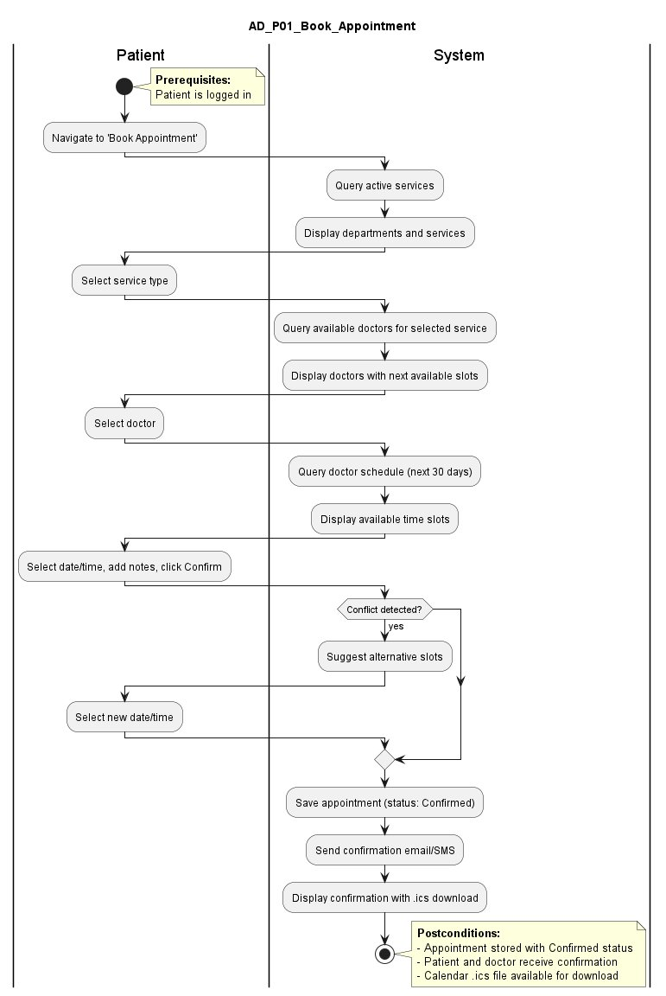

9.2 UC_P02: Cancel or Reschedule Appointment
Activity diagram for UC_P02: Cancel or Reschedule Appointment.
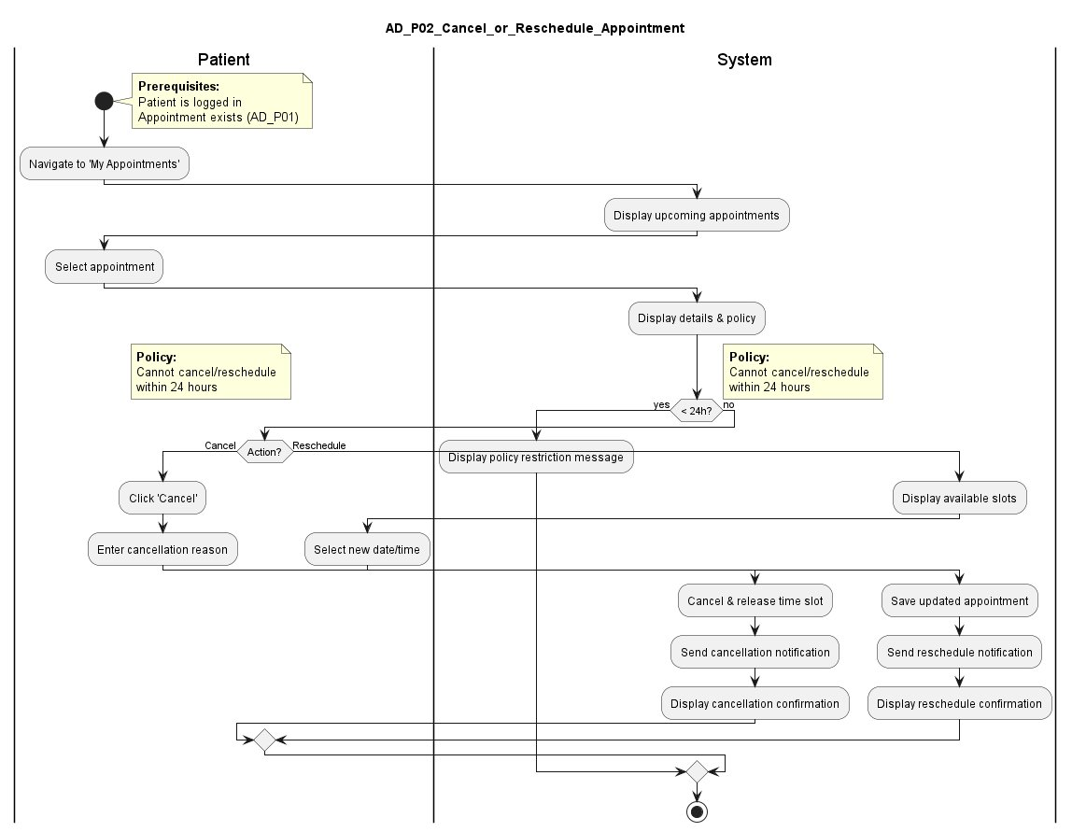

9.3 UC_P03: View Test Results
Activity diagram for UC_P03: View Test Results.
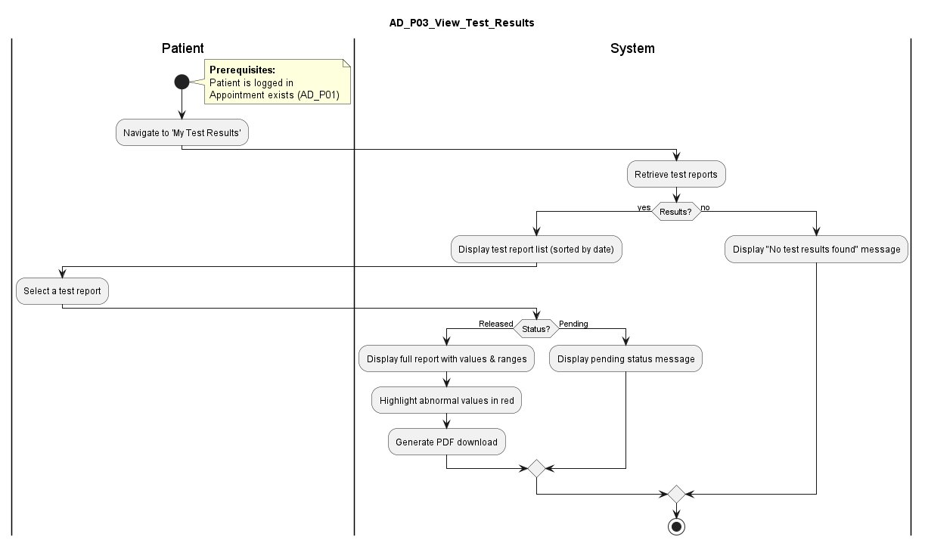

9.4 UC_P04: View Medical Record Summary
Activity diagram for UC_P04: View Medical Record Summary.
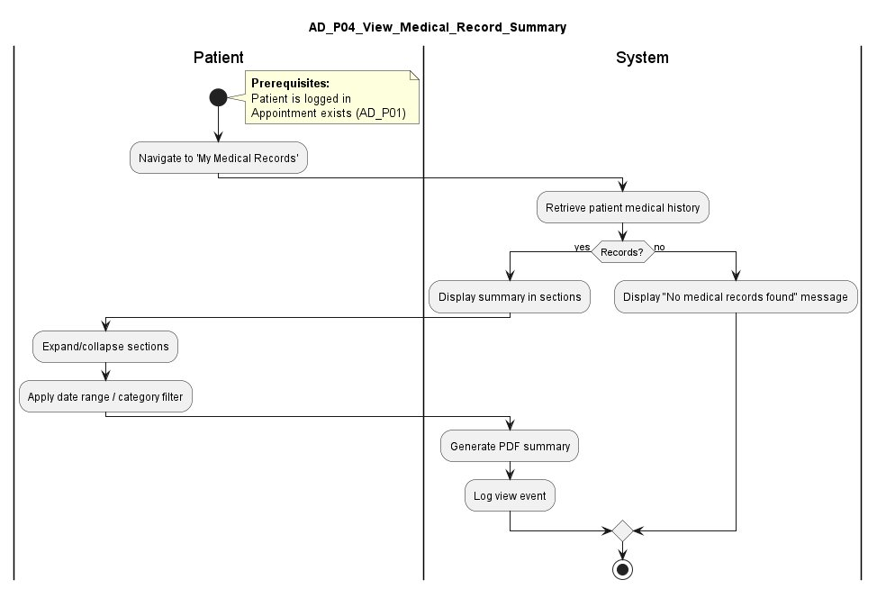

9.5 UC_P05: View Bills and Payment Status
Activity diagram for UC_P05: View Bills and Payment Status.
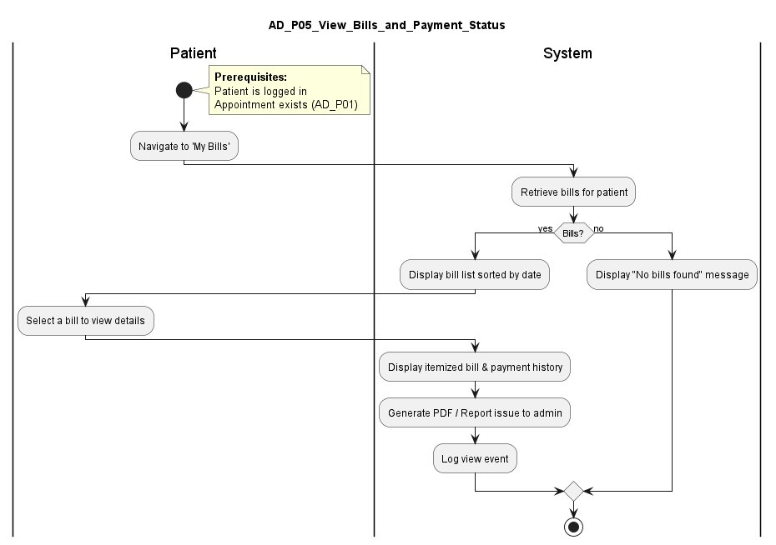

9.6 UC_P06: Track IVF Cycle Progress
Activity diagram for UC_P06: Track IVF Cycle Progress.
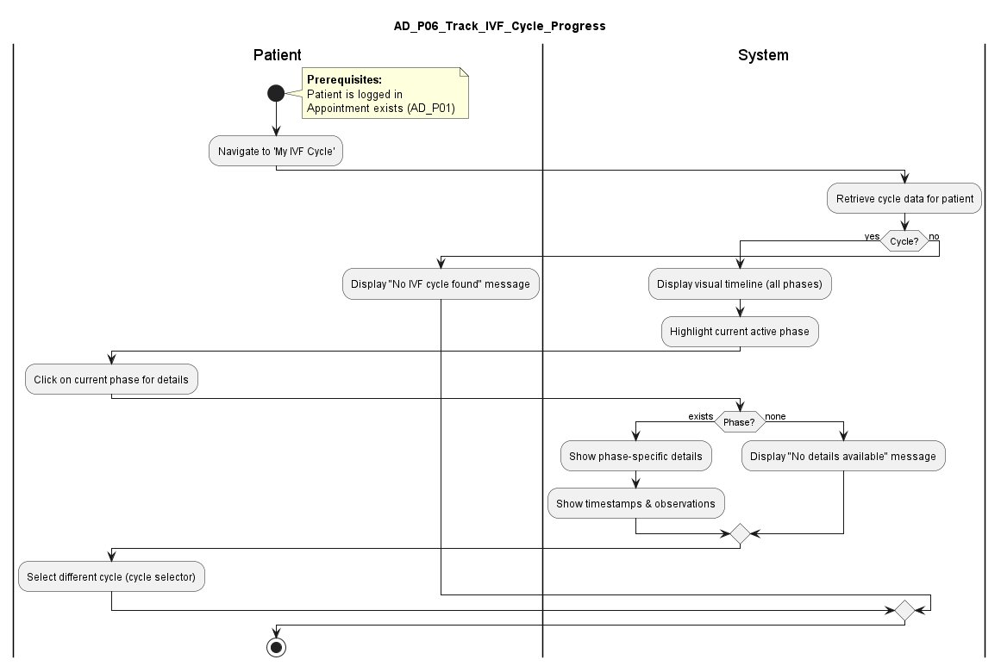

9.7 UC_P07: Receive Notification Reminders
Activity diagram for UC_P07: Receive Notification Reminders.
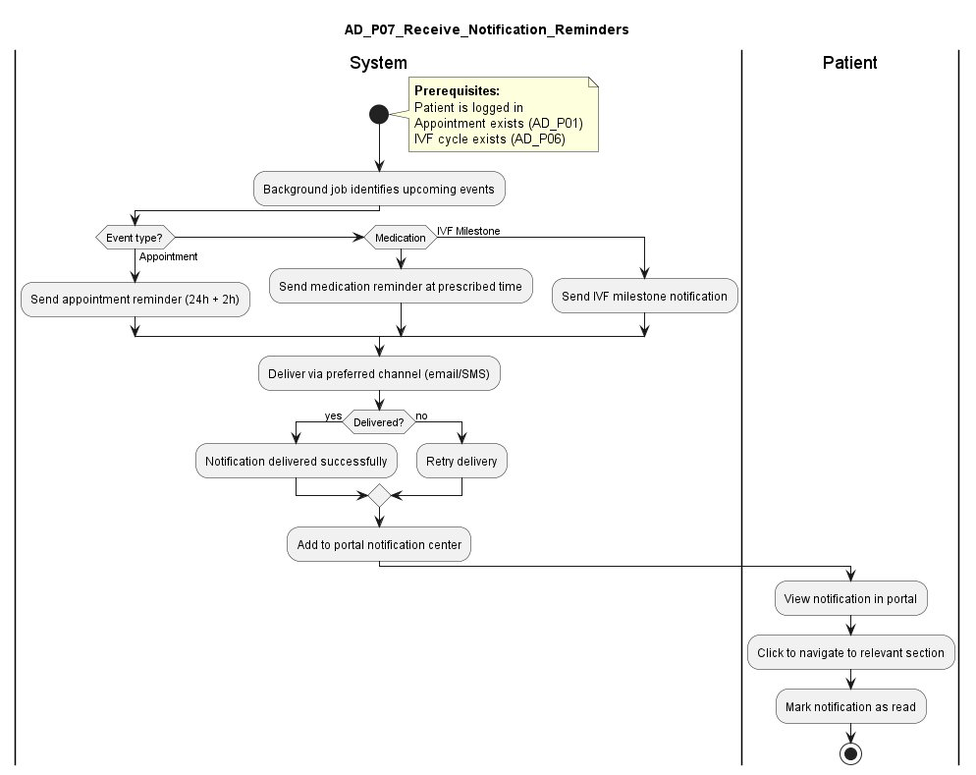

9.8 UC_P08: Submit Feedback
Activity diagram for UC_P08: Submit Feedback.
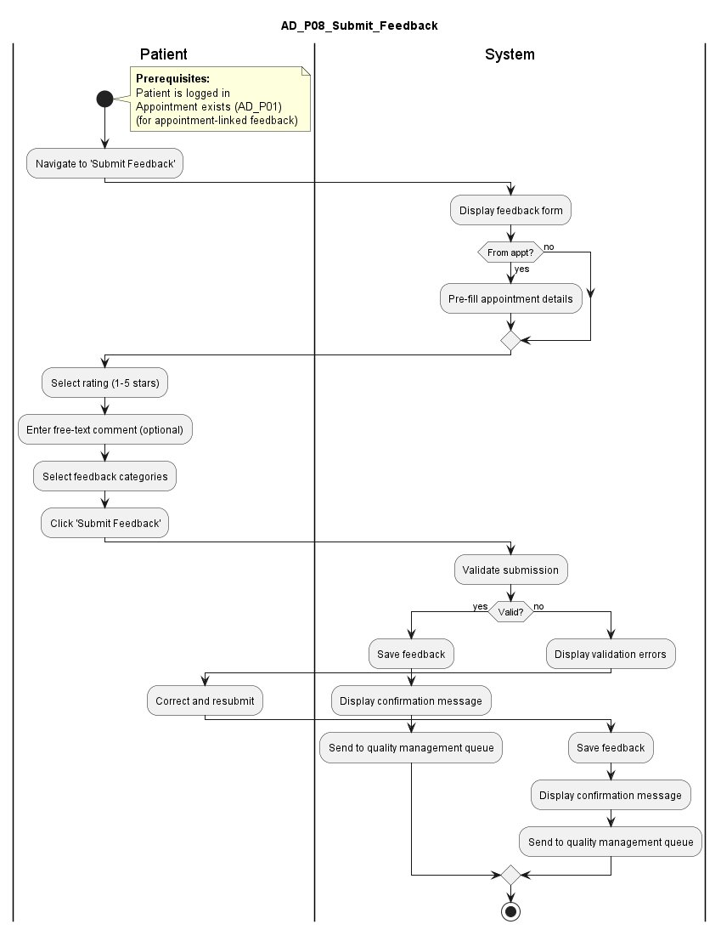

10. Sequence Diagrams
This section contains the sequence diagrams for each patient use case. Each diagram illustrates the chronological interactions between the patient, the portal UI, backend controllers, services, the database, and external components such as notification services. Diagrams in this section are rendered in landscape for readability.

10.1 UC_P01: Book Appointment
Sequence diagram for UC_P01: Book Appointment.
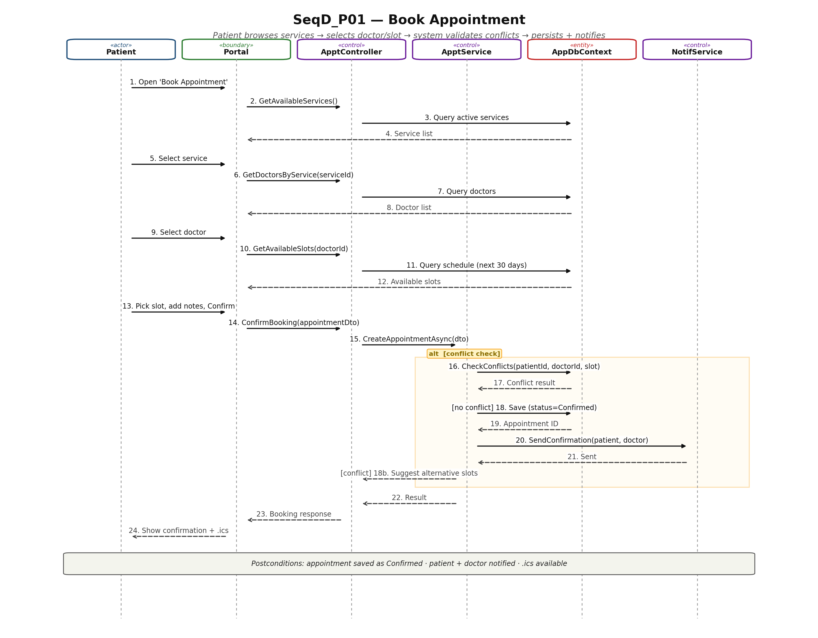

10.2 UC_P02: Cancel or Reschedule Appointment
Sequence diagram for UC_P02: Cancel or Reschedule Appointment.
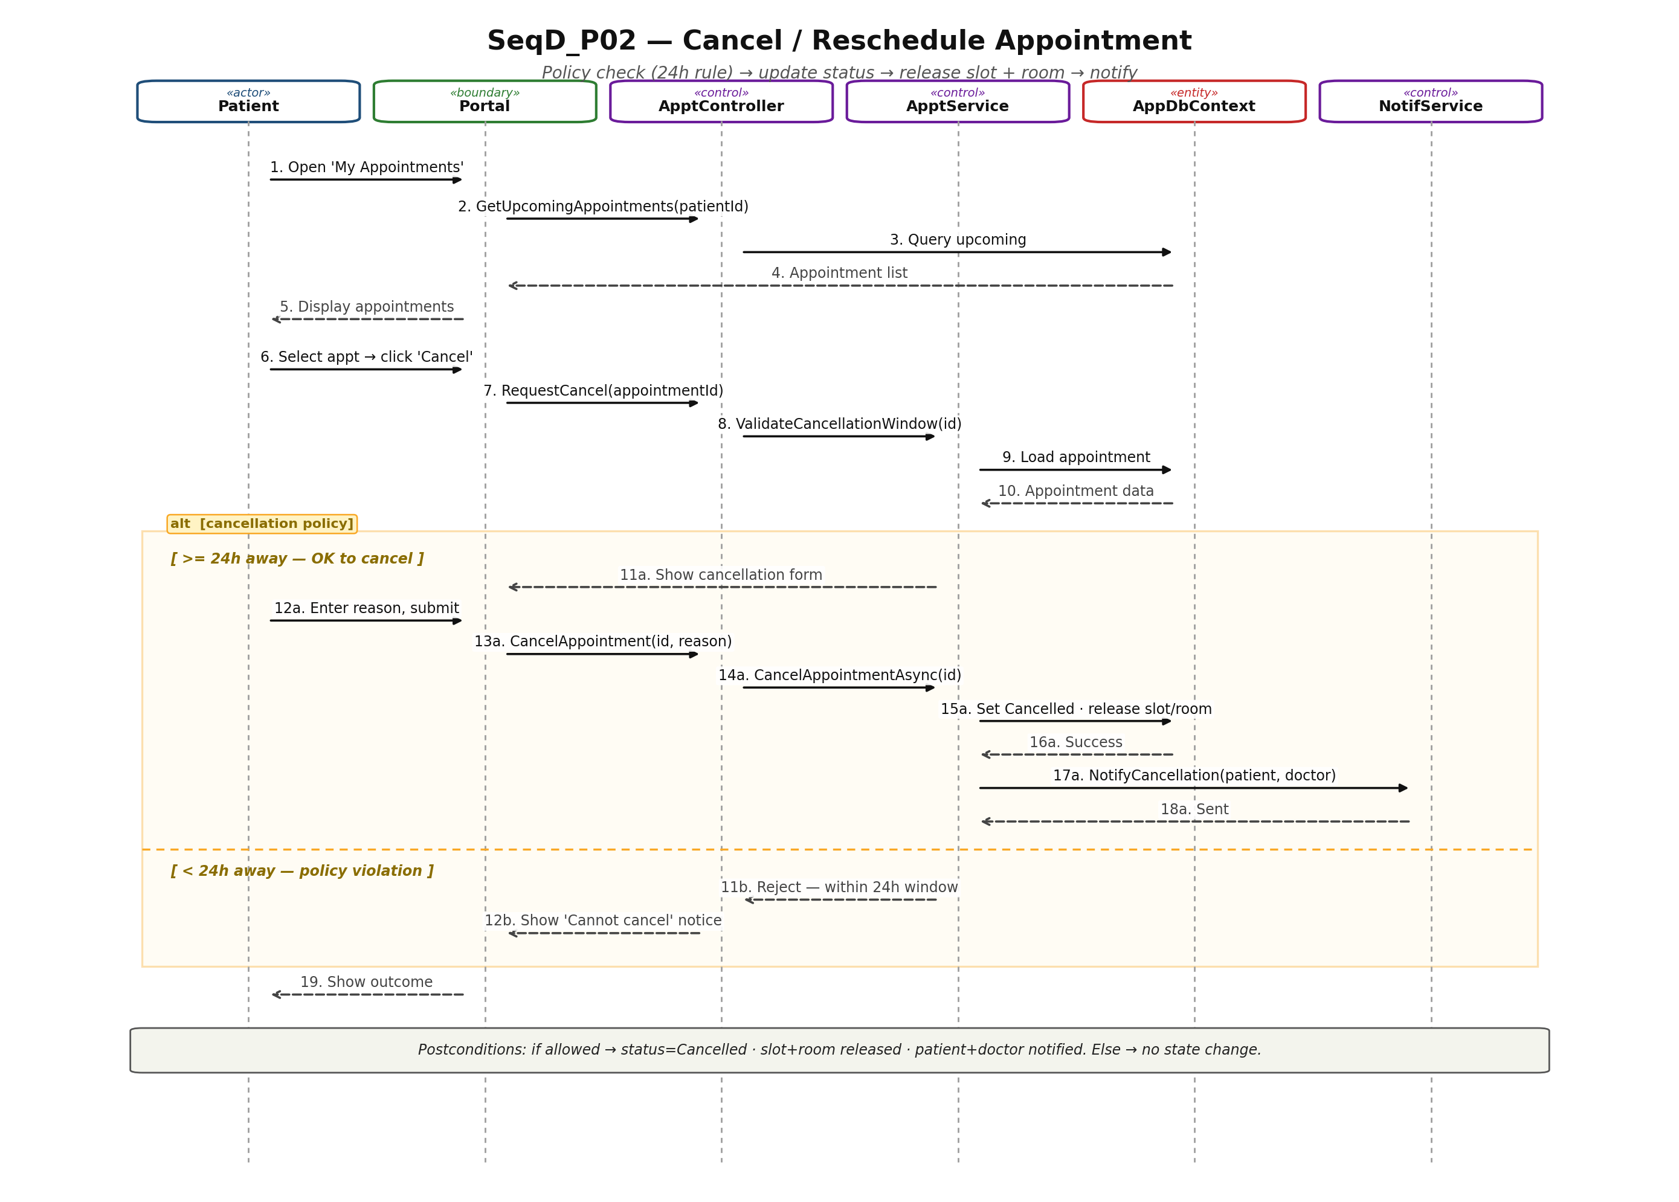

10.3 UC_P03: View Test Results
Sequence diagram for UC_P03: View Test Results.
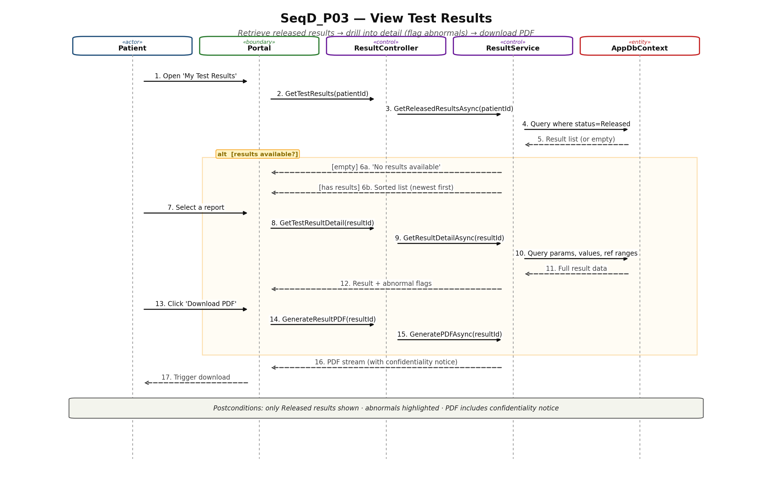

10.4 UC_P04: View Medical Record Summary
Sequence diagram for UC_P04: View Medical Record Summary.
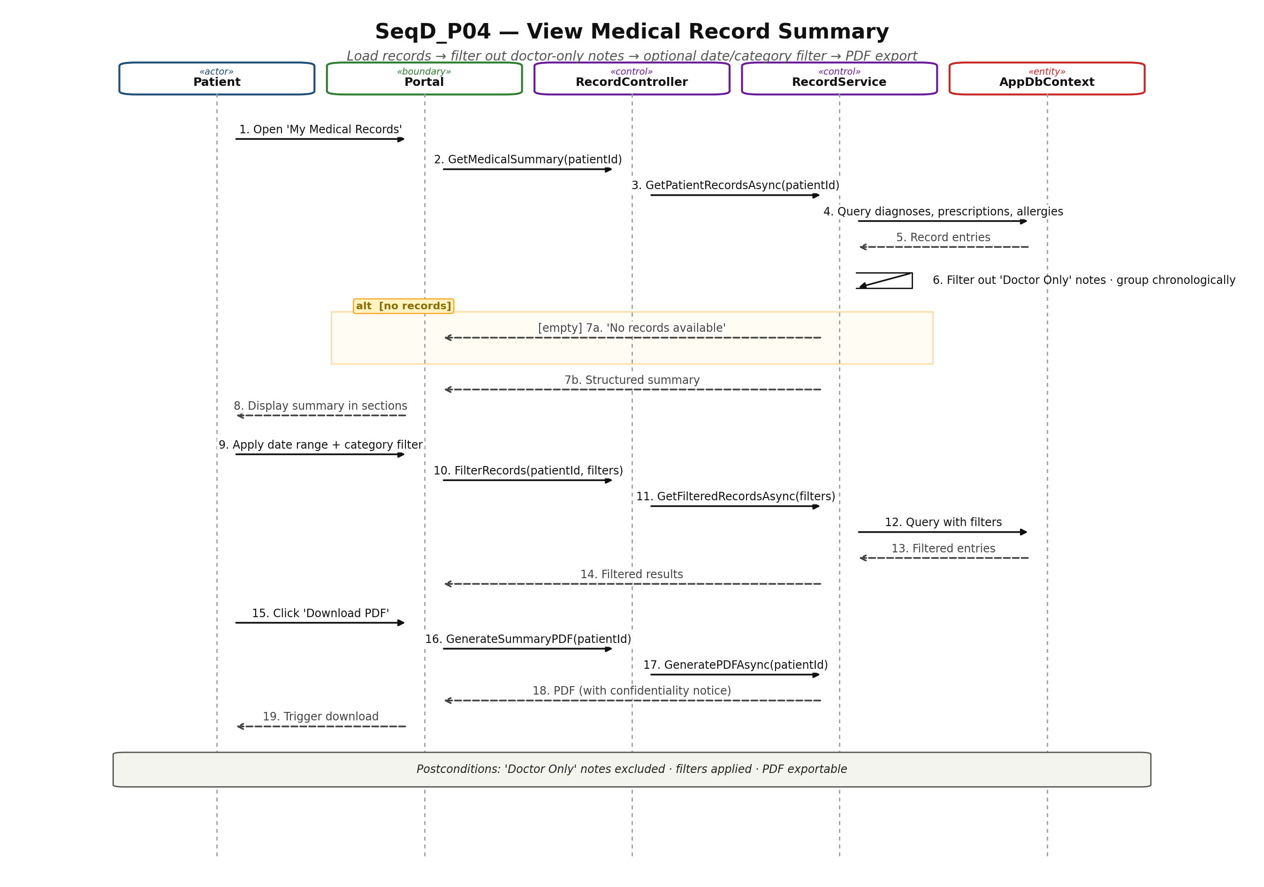

10.5 UC_P05: View Bills and Payment Status
Sequence diagram for UC_P05: View Bills and Payment Status.
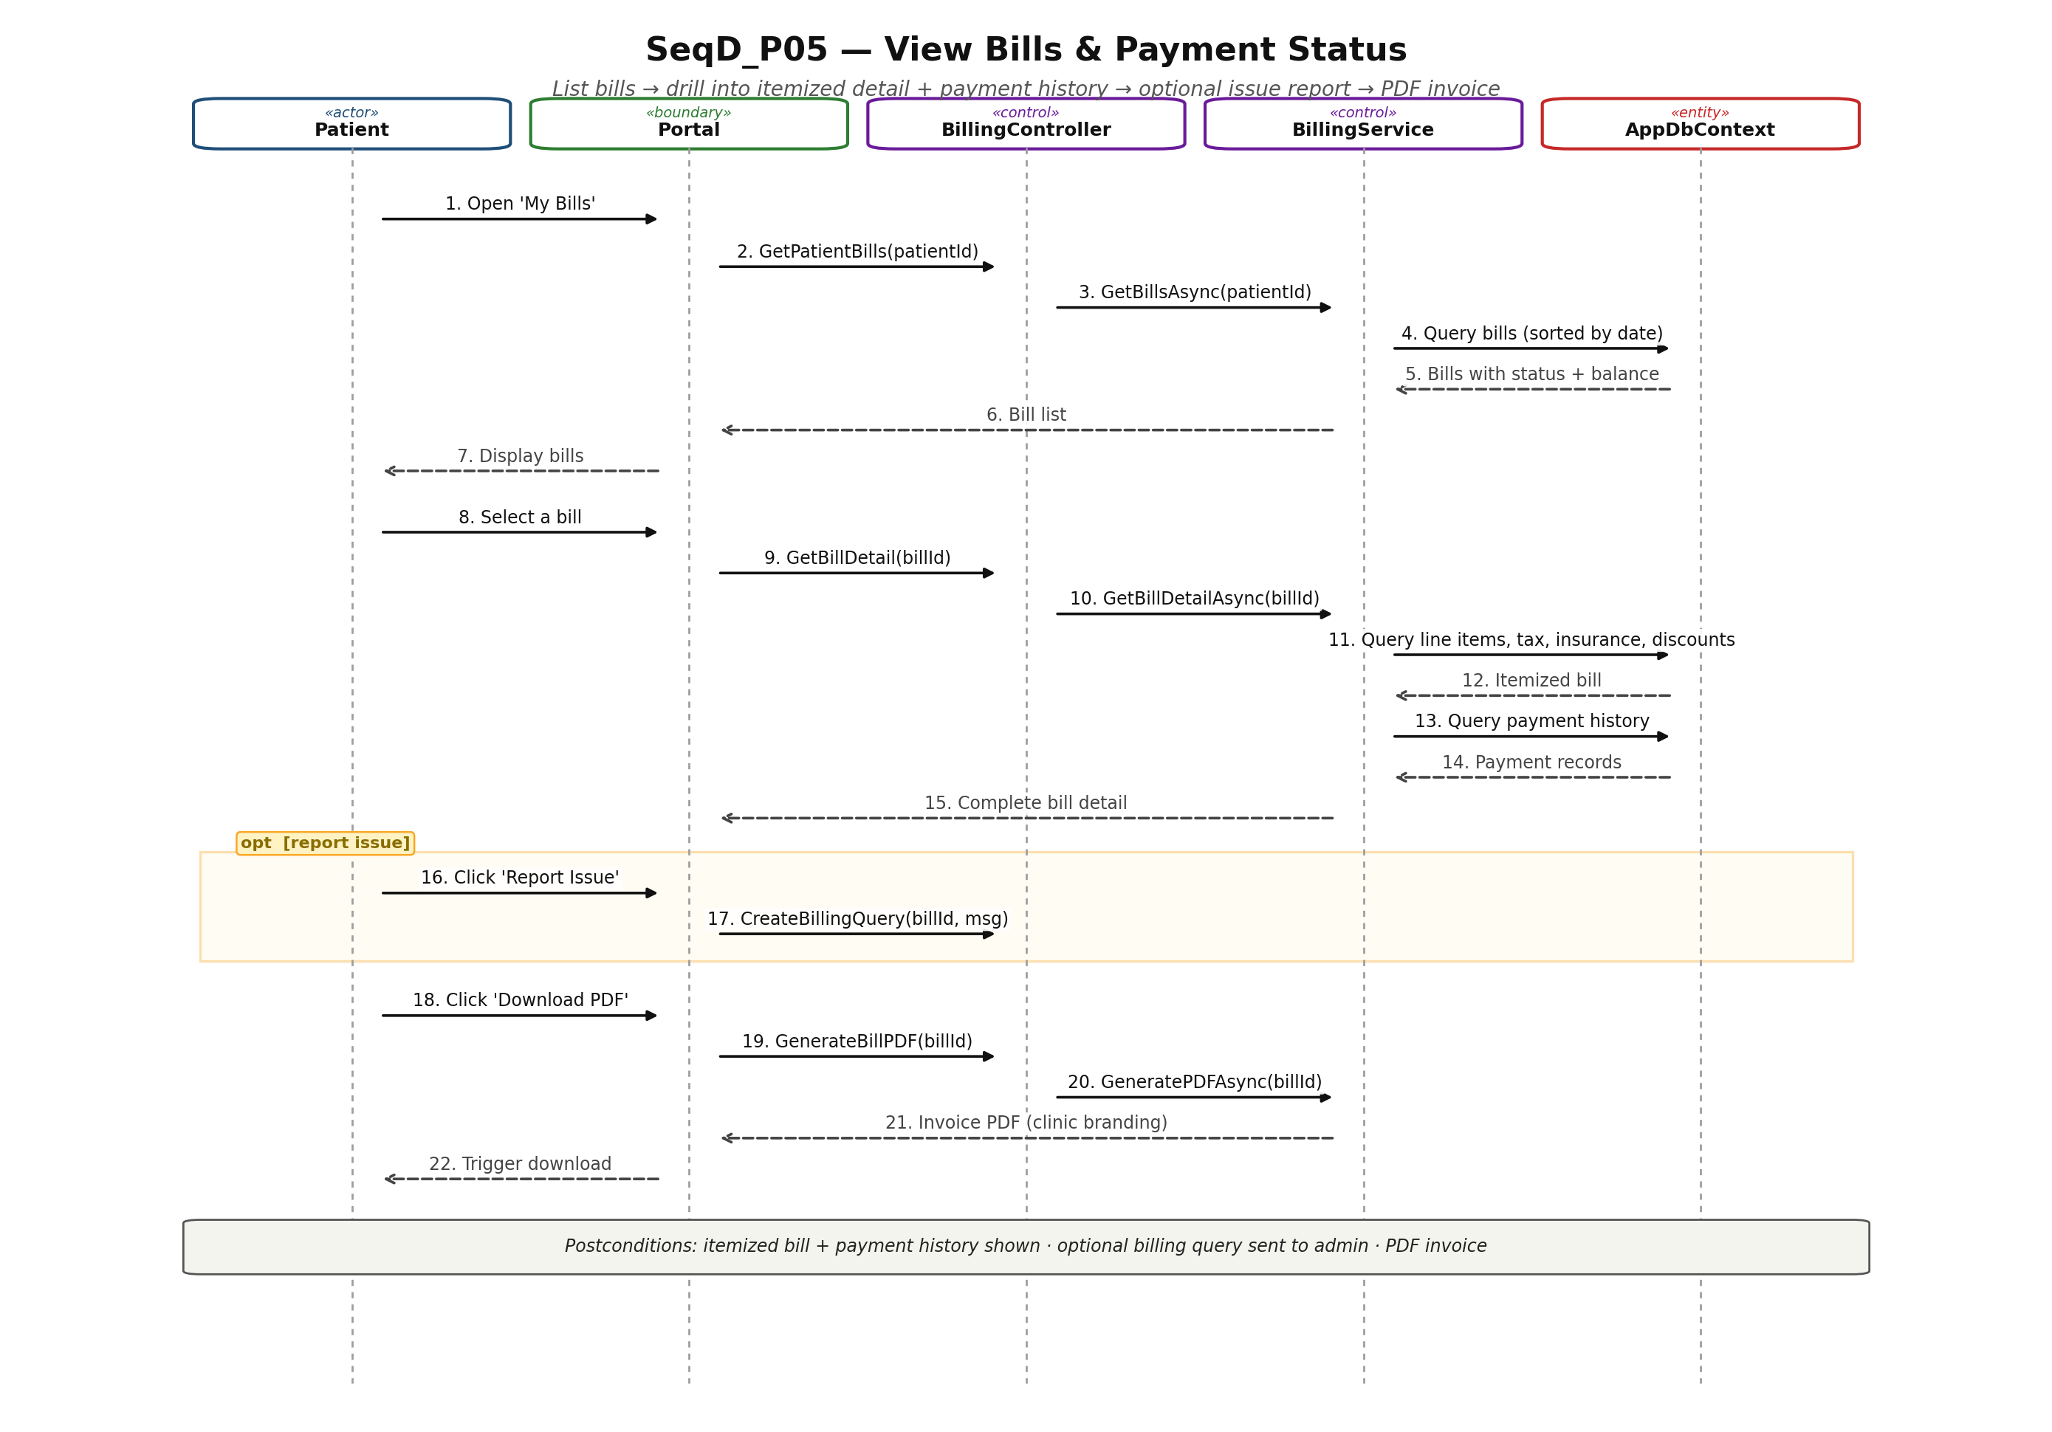

10.6 UC_P06: Track IVF Cycle Progress
Sequence diagram for UC_P06: Track IVF Cycle Progress.
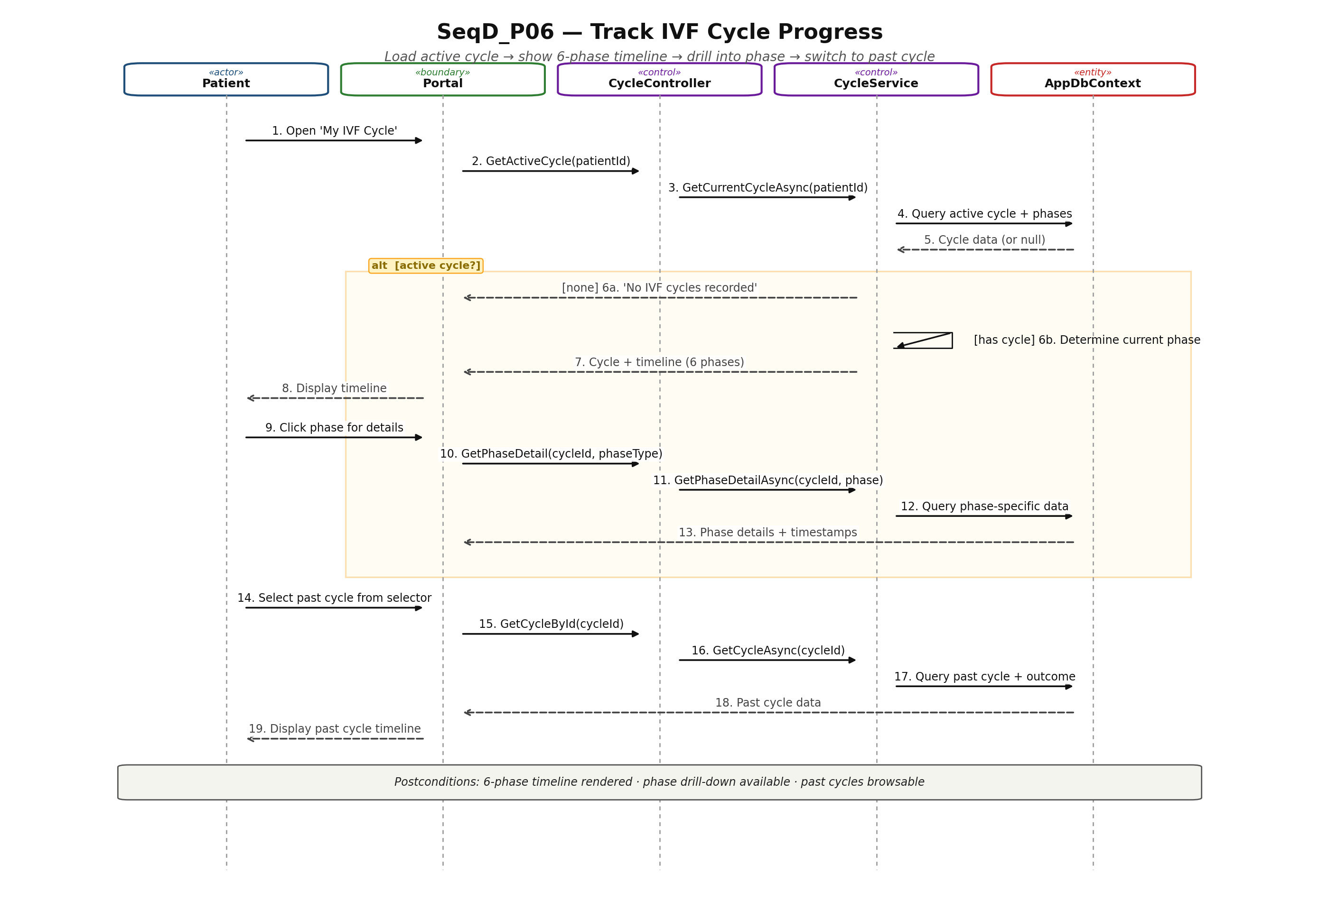

10.7 UC_P07: Receive Notification Reminders
Sequence diagram for UC_P07: Receive Notification Reminders.
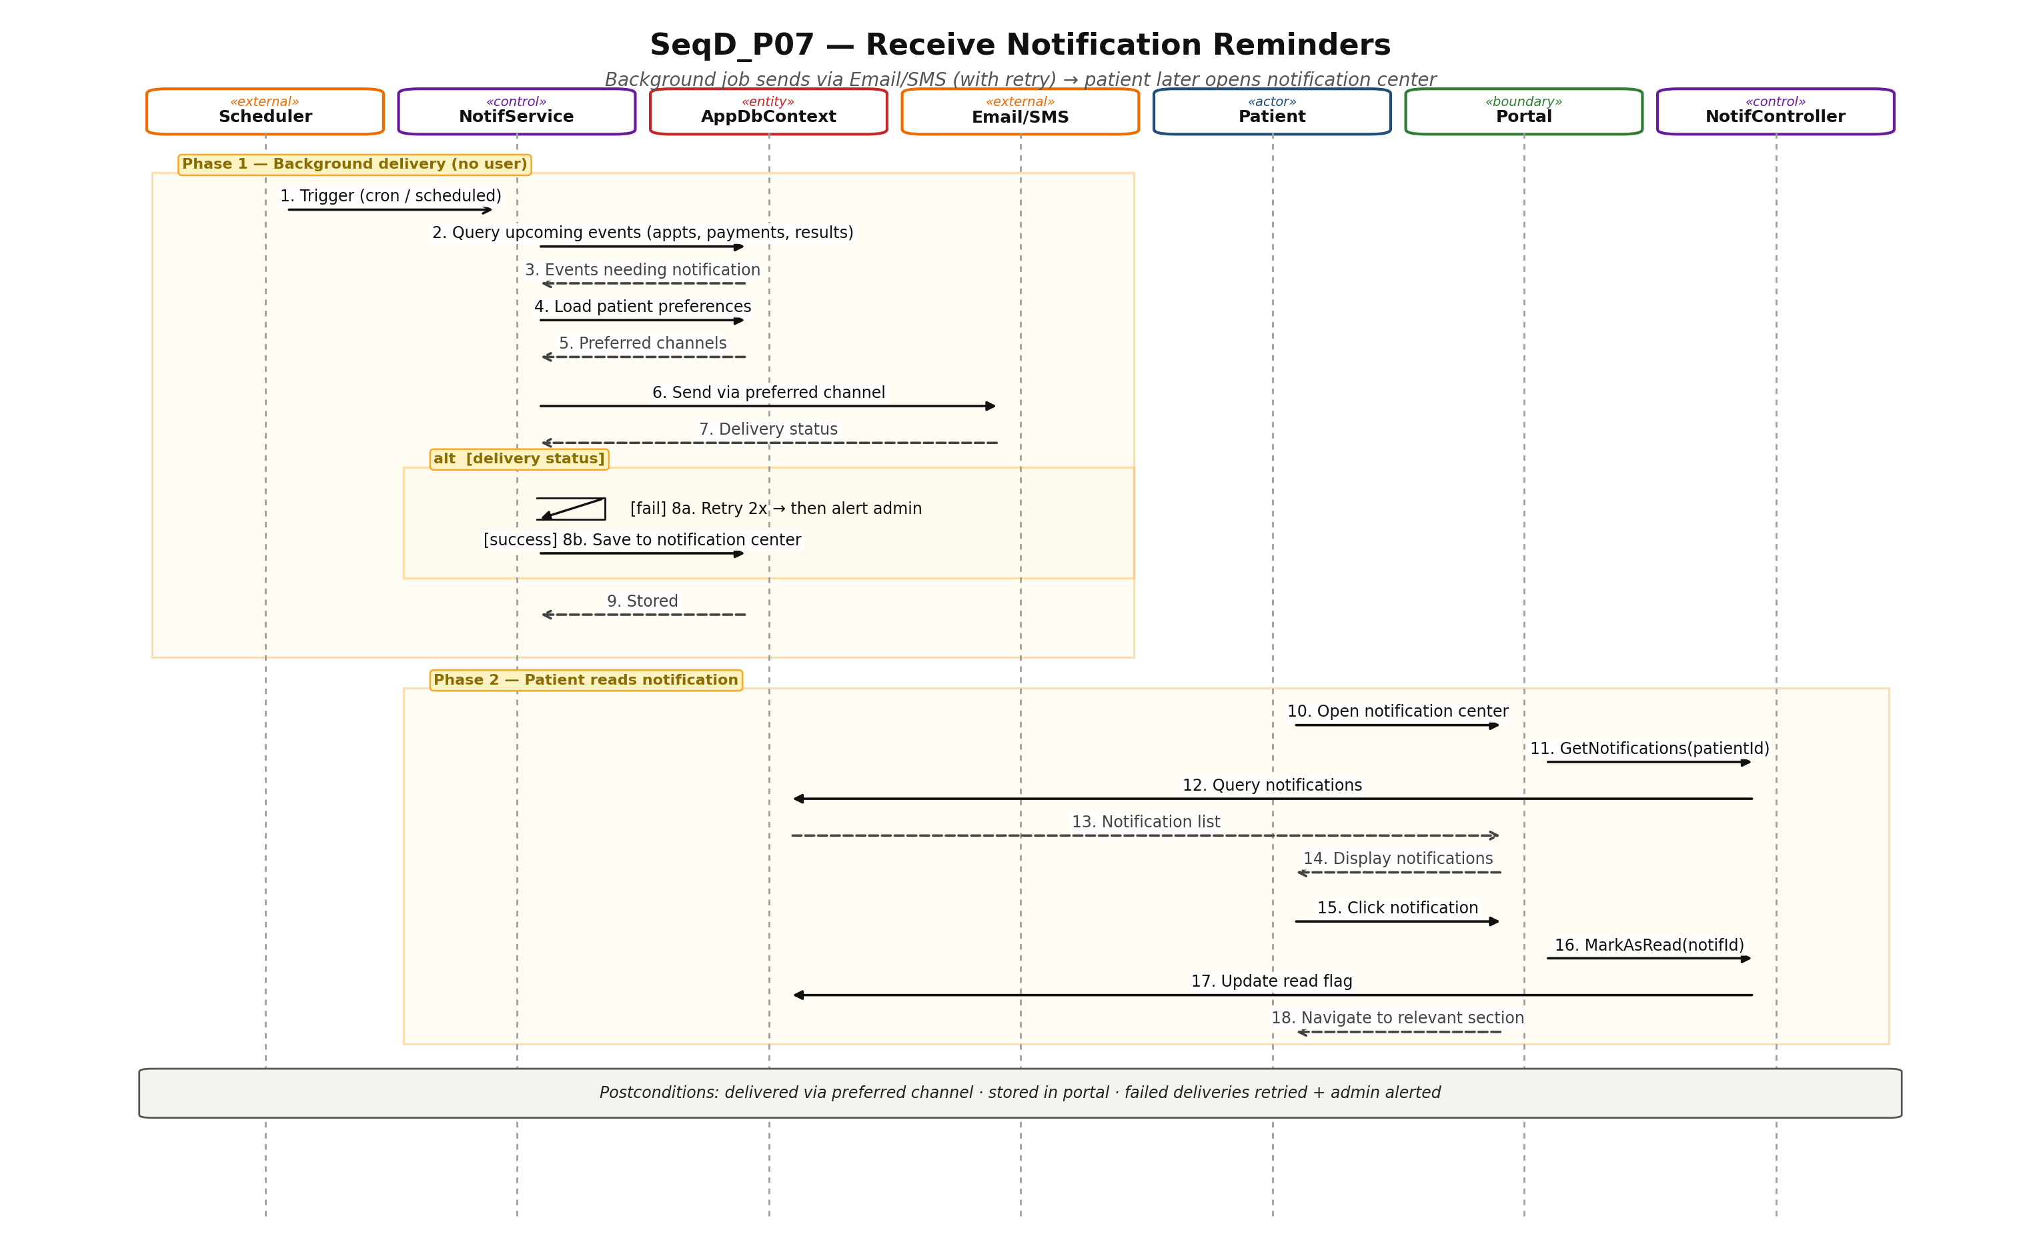

10.8 UC_P08: Submit Feedback
Sequence diagram for UC_P08: Submit Feedback.
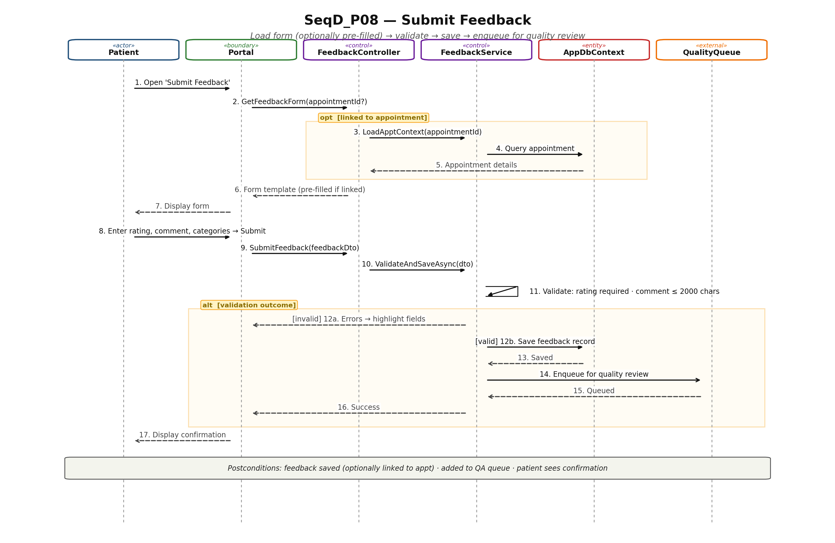

11. State Diagrams
This section contains the state diagrams for each entity the patient interacts with. Each diagram shows the lifecycle states, transitions, and entry/do/exit actions following UML state diagram notation. Diagrams will be inserted in a subsequent deliverable; the scope of each is summarized below.

11.1 ST_Appointment: Appointment (patient-owned lifecycle)
States: Draft → Confirmed → (Rescheduled | Cancelled | Completed | NoShow). Transitions triggered by patient booking, cancel, reschedule, and system completion/no-show detection.
State diagram for ST_Appointment — to be inserted.

11.2 ST_TestResult: Test Result (patient visibility lifecycle)
States from the patient's perspective: Pending → UnderReview → Released (visible to patient) → Viewed → Downloaded. Transition to Released requires doctor authorization.
State diagram for ST_TestResult — to be inserted.

11.3 ST_Bill: Bill
States: Pending → (PartiallyPaid → Paid) | Disputed (via patient Report Issue). Patient can observe status changes but cannot trigger transitions (admin-controlled).
State diagram for ST_Bill — to be inserted.

11.4 ST_IVFCycle: IVF Cycle
States: Initiated → Stimulation → EggRetrieval → Fertilization → EmbryoCulture → Transfer → LutealPhase → (Success | Failed | Cancelled). Phase transitions require doctor authorization.
State diagram for ST_IVFCycle — to be inserted.

11.5 ST_Notification: Notification
States: Scheduled → Sending → (Delivered | Failed → Retrying → (Delivered | PermanentlyFailed)) → (Unread → Read). Patient can mark notifications as Read.
State diagram for ST_Notification — to be inserted.

11.6 ST_Feedback: Feedback
States: Draft → Submitted → Queued (in quality management) → (Reviewed → Responded) | Archived. Once Submitted, patient cannot edit.
State diagram for ST_Feedback — to be inserted.

11.7 ST_PatientAccount: Patient Account
States: Registered → Active → (Locked | Deactivated). Locked triggered by 5 failed login attempts; unlocked by administrator.
State diagram for ST_PatientAccount — to be inserted.

